Environment (Wales) Act 2016 Part 1 - Section 6
The Biodiversity and Resilience of Ecosystems Duty Report 2019
Introduction and Context
Nature is declining globally at rates unprecedented in human history and the rate of species extinctions is accelerating, with grave impacts on people around the world now likely. The Environment (Wales) Act 2016 (the Act) introduced an enhanced biodiversity and resilience of ecosystems duty (the section 6 or s6 duty) for public authorities (PAs) in the exercise of functions in relation to Wales. The s6 duty requires that public authorities ‘must seek to maintain and enhance biodiversity so far as consistent with the proper exercise of their functions and in so doing promote the resilience of ecosystems’. To comply with the S6 duty public authorities should embed the consideration of biodiversity and ecosystems into their early thinking and business planning, including any policies, plans, programmes and projects, as well as their day to day activities.
More information about the Wales Biodiversity Partnership can be found at the following link: https://www.biodiversitywales.org.uk/

Bishton Community Council
Bishton Community Council (BCC) lies in the Llanwern electoral district (ward) and encompasses the villages of Wilcrick, Underwood and Bishton with approximately 2000 residents.
Wilcrick.
‘Wilcrick’ is a welsh name which translates as ‘bare hill’ – the hill referred to is now tree clad and is the location of an iron age fort from where extensive views down the Severn Estuary are afforded; essential for an early warning of Irish invasion up the estuary. The tiny church of St Mary the Virgin, is located on the lower slope of the hill and once served a much larger settlement abandoned during the middle ages in common with several other locations in the local area.
The church has its points of interest and its curiosities – it is necessary to present the key to the south door ‘upside-down’ to gain entry! The church was entirely rebuilt in 1860, but it retains a vase like 12th century font, a tablet to an 18thcentury rector who ministered here for an incredible 57 years, late 17th or early 18th century altar rails and a bell of 1726 cast by the Evans foundry of Chepstow.
The Victorian glass within the east window features the four evangelists. Also look out for a stone seemingly randomly located within the east wall, bearing the date 1621, as well as the pedestal sundial. The church has recently been redecorated and is much loved by a small, but committed congregation.
Bishton.
Bishton or Bishopston (Welsh: Llangadwaladr Trefesgob or simply Trefesgob) is a small rural community in the east of the city of Newport, South Wales. The name is said to derive from "Bishop's Town", as the village has been alleged to the sometime home of the Bishops of Llandaff. Owain Glyndŵr destroyed the palaces at Bishton and Llandaff, from which time the episcopal palace was moved to Mathern. Bishop John Pascall died here of the plague in 1361.
Bishton Saint Cadwaladr Church is the only church is the country dedicated to Cadwaladr, although it is possible that St Mary's Church, Magor also was originally dedicated to him. Cadwaladr was the last Welsh ruler to call himself King of Britain and he earned the title "blessed" for his peaceful disposition. He died of the plague in 664 AD.
The original decorated and perpendicular church was damaged in 1760 when part of the tower collapsed into the nave. Considerable rebuilding and restoration was required. The north porch is a 19th-century addition. Whilst some of the lancet windows are original, the east window, the west tower window and the two south windows to the nave are Victorian insertions. The origins of the chancel arch are unclear and it seems to have been reconstructed from earlier stonework, incorporating medieval corbel heads of a monk, a nun, a man and a woman. The stoup is located near the north door. The font is a late medieval piece. The stained glass to the east window, which depicts Christ as the Light of the World and as the Good Shepherd, dates from about 1915. Use of the Welsh language in services continued at the church until 1828.
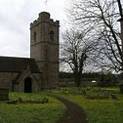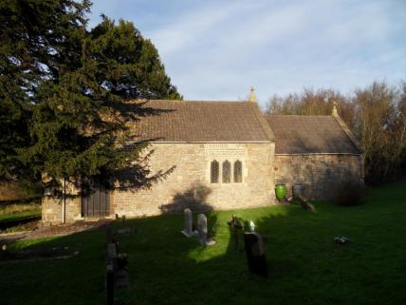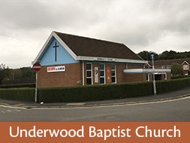
St Cadwaladr, Bishton St Mary the Virgin, Wilcrick Baptist Church, Underwood
Underwood.
The Underwood Estate was originally developed from the former World War II Prisoner of War camp after the end of the war. A few surviving examples of the former PoW huts were still visible until the early 1990s when they were demolished. The original huts stood as early community buildings. In the early 1980s several huts and a water tower were also visible on the now Waltwood Park Drive area, this area belonged to the General Post Office and was used to house old telecommunications equipment until it was sold and demolished by British Telecom who took over the site when BT was privatised in the early 1980s. The land was subsequently sold to Westbury homes who built the Waltwood Park Drive Development of around 220 houses on the land.
The estate is situated in a natural land formation within the falls of a wooded area on the south and north side and a small drainage ditch or reen called "Monks Ditch" on the northern side of the development. Built in three phases, with the Waltwood Park Development being the last of the three phases.
Many people believe that the Underwood Estate was created for the local steelworks at Llanwern, as it was constructed at the same time as the Richard Thomas and Baldwins "Spencer Works" was being built. This has some truth, as originally people moved into the huts after the war. However the local council at the time, Magor and St Mellons Rural District Council, created the housing estate with post-war initiatives for more housing, hence why the second phase of the housing development consists of rapid construction poured concrete houses which are very sturdy in construction and much stronger than traditional bricks-and-mortar houses.
Bishton Community Council (BCC) provide a range of services to the communities which impact on how we view our environment as well as on local biodiversity. These include:
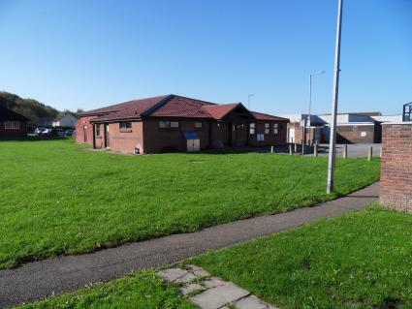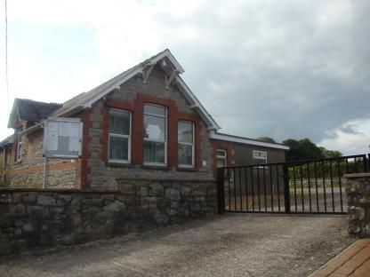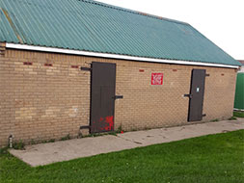
Underwood Community Centre Bishton Village Hall Football Changing Rooms
- Facilities. BCC have responsibility for a number of green spaces including a play park a sports field and a Cycle Speedway for community use. We also own and maintain a Community Centre in Underwood and a Village Hall in Bishton The local Underwood FC football team changing rooms are maintained by BCC but the team is organised and run by volunteers who are local residents. The football field is secured on a long lease to BCC from Newport City Council. The Underwood Flyers cycle speedway is located at the south end of Underwood Village and is organised, financed and run by volunteers who are also local residents. There are also 3 churches within the BCC area, 2 of which have graveyards, and an allotment site with 40 allotments for use by local residents.
Biodiversity
- Allotments. BCC provide allotments for local residents to promote a ‘grow your own’ culture. This is not only beneficial as a food source to those that use them but also helps to keep those who are retired fit and occupied, as well as providing an educational opportunity to allotment holders with young children so they can learn how vegetables are grown and hopefully develop the taste for home grown produce and, perhaps, fan an interest for there own garden when they are older. The allotments are wedged between the M4 motorway on one side and surrounded by trees and brush on the other three, thus providing bees, butterflies and other insects with nourishment for most of the year.
- Most allotments are quite large (10m x 30m) which are too much for some people to work. In support of Project 21 we have ideas to split some plots which become vacant and equip them with raised beds before rehiring. These are intended for those residents who have difficulty bending but still have an interest in gardening and ‘growing their own’.
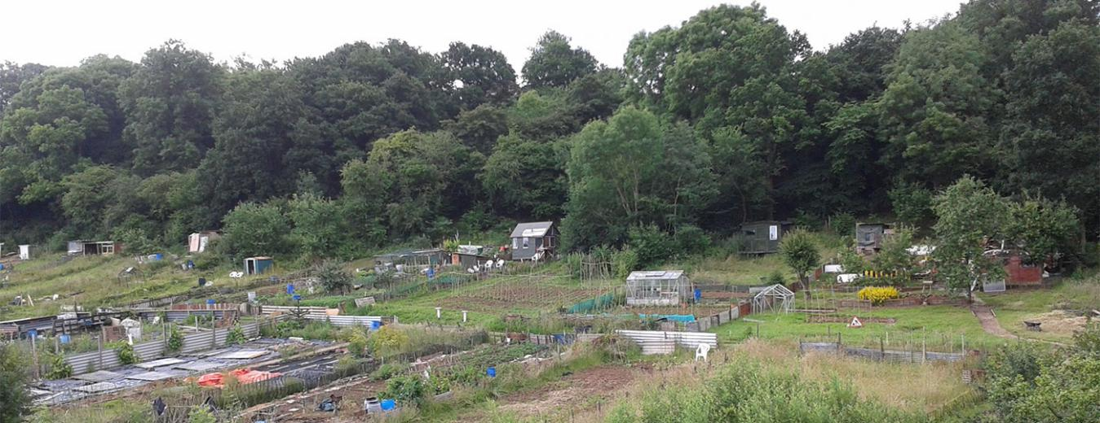
Allotment holders are permitted to keep a small number of chickens. Interest has recently been expressed to keep Bee Hives on the allotments. Although we generally support the idea advice is currently being sought regarding council & bee keeper responsibilities prior to permission being granted.
- Planters. We have 21 planters and a small memorial garden located around the communities which are maintained by a small number of volunteers. The planters not only fulfil the goal of increasing the optical impression of a community that cares about its environment but also provides vital nourishment for a wide variety of insects that we also need for pollinating other fruit bearing plants in our own gardens. Plants in the planters blossom at different months throughout the year thus providing a continuous valuable food source for insects over a longer period.
- Project 21. In November 2020 BCC introduced an initiative to increase the number of flowers beds and trees providing not only more feeding opportunities for insects but also to increase the optical appearance of BCC area.
  - Bishton Memorial Garden & Pond. In 2019 the residents of Bishton created small a garden with a Memorial Bench in honour of a former resident. This is being extended with plans to recreate a small pond next to the site which will be lined and planted with water flowers & plants which will not only provide an optical improvement to the area but also provide a habitat for insects as Bishton lies on the edge of the Gwent Levels which is rich in biodiversity.
  - Underwood Flower Beds. Newport City Homes (NCH), who manage Underwood estate, have been approached to allow BCC to create flower beds in key area around the estate. Sites have been identified and WG Funding is available to support projects like this but discussions with NCH are still ongoing and we need their support before we can move forward with this idea.
- Community involvement. BCC organises an annual ‘Best Gardens’ competition for the residents of the communities. Awards are presented for categories of Best Garden, Best Hanging Basket / Flower Pots and for Best Allotment.
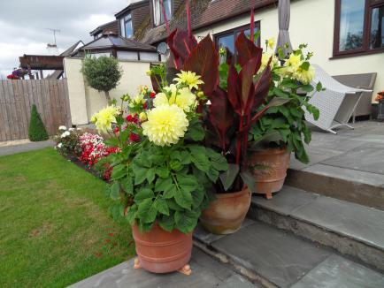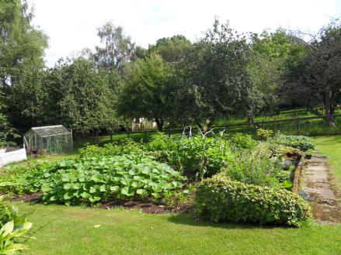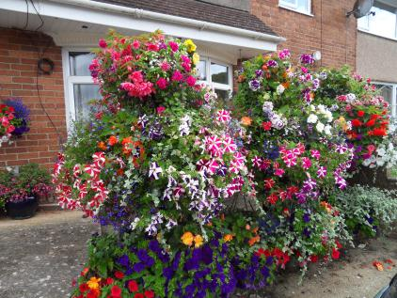
Once again this generates interest in maintaining the image of a community that cares about the environment they live in as well as providing a vital food source for bees and other insects.
Llanmartin Primary School is located in Underwood. We have offered 6 planters nearest to the school to be sponsored by different classes to plant and maintain. This will hopefully inspire the children to generate an interest in plants and understand the important role they play in our environment.
- Fields in Trust. There is also another sports field area that is owned by Newport City Council. We are currently negotiating with Fields in Trust to protect this land with a long term lease. This would not only preserve an open space for community use for the foreseeable future but it would also ensure the verges, ditches and shrubbery surrounding the area are not destroyed. These areas are important habitats for a wide variety of fauna, flora and many species of wild life, some of which are endangered.
- Gwent Levels. We have just negotiated with the Living Levels Hub Scheme for them to provide an Interpretation Panel which will highlight the qualities of the Gwent Levels and to increase public awareness of the vast diversity of fauna & flora and its importance in maintaining a balanced ecosystem.
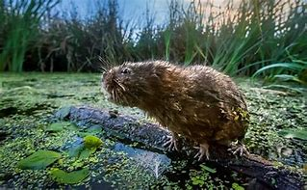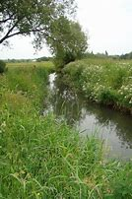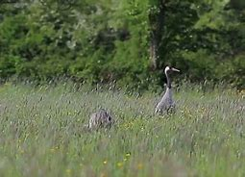
Historically BIshton Community Council opposed the plans for a motorway across the Gwent Levels proposed by the Welsh Government over the last 25 years or so. The need to protect the biodiversity and landscape of the Levels was a major motive for this stance, and it was of course central to the final decision by the Government to reflect the final version of the proposals in 2019. Individual members of the Council were prominent in CALM (the Campaign Against the Levels Motorway), on a personal basis. In 2017 the Council made two specific interventions with the M4 Public Inquiry. In April the Council wrote complaining about the procedures because they were allowing too many alternative routes to be considered at short notice. The Council’s objection was expressed in strong terms :
“The document now throws another 20 different route variations onto the table, including unrealistically expensive ideas such as a tunnel under the entire area. Amongst them are variations which have never been the subject of any previous consultations including two routes which would smash the route through fields 400 metres from Bishton village and 100- 200 metres from Wilcrick, which are both in our Council’s area. The character and setting of both villages would irreparably changed by such a proposal.”
We highlighted the “enormous impact of the proposals on the villages, countryside, wildlife and heritage assets close to the green route, and the people of Bishton and Wilcrick”. Evidence given by expert witnesses was quoted in support of our objection.
- Llanmartin Primary School
In March 2021 Llanmartin Primary School was successful in their application to join the Young Tree Champions programme along with 2500 other schools in England and Wales. As part of the programme the school received five beautiful trees for the children to plant and grow on the school grounds, a ‘tech’ kit including a microscope, camera and virtual reality headset and tailored teacher training and pupil workshops.
The children are taught why trees are important for the environment and a #ForceForNature to restore the natural balance of life. During the year the school is evaluated for the work the children do toward the ‘Young Tree Champion’ award scheme
At a live ‘Force for Nature’ awards event, Llanmartin Primary School was one of two schools (equally awarded) that are the Outstanding Tree Champions.. This is in recognition of the incredible work that all the classes have been carrying out during the 2021 Summer term.
- Funding - BCC award grants for local causes and projects in the Council area. This positively impacts on biodiversity through cascading funding criteria. We promote sustainability and biodiversity by pursuing sustainability goals and sustainable practices whenever possible. We are currently negotiating with Renew Wales for Climate Top Up Grant funding to install Solar Panels on the Community Centre and we will also convert to LED lighting in all the rooms to make the building more environmentally sustainable and energy efficient.
We also intend to convert to LED lighting in Bishton Village Hall. However, due to the specific type of roof construction it is not suitable for installation of solar panels.
BCC serves approximately 2000 residents within the 3 communities.
Annual Review of s6 Duty 2021.
- What has worked well?
  - Underwood Allotments have continued to thrive despite COVID restrictions. This has not only benefited providing pollinating plants for insects but also allowed people to remain active and enhanced individual well-being during the various lockdown periods.
  - Although many planters have not been maintained as we would have liked them, perennials that were planted and wild flowers have been a continual source of colour whilst providing a food source for insects.
- What have the barriers been?
  - COVID 19 restrictions and closure of Garden Centres have had an effect on the number of flowering plants being purchased with the knock on effect that our annual garden competition was also cancelled. It will be reinstated when conditions allow.
- What changes need to be made?
- Are there any additional factors to consider to improve the environment and biodiversity in our area.
  - BCC has launched Project 21 to create flower beds and plant trees within the council area to enhance the visual impact of colour in the villages whilst at the same time providing a much needed food source for pollinating insects. This is an ongoing project that requires the support of the local Housing Association as the areas identified around Underwood estate are their responsibility and we are continuing to negotiate with them. Residents of Bishton, with the support of BCC, continue to improve the memorial garden and pond area which will also benefit pollinating insects.

